Creative Curriculum Overview- EYFS

Term | Projects | Overview
Autumn 1 | Me and my Community  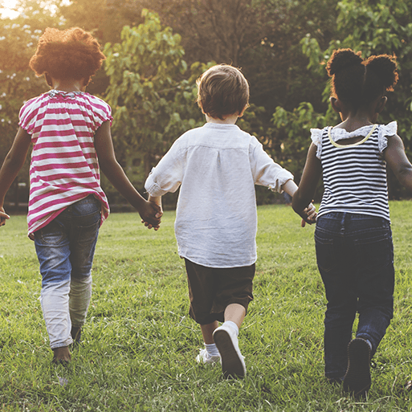  Exploring Autumn  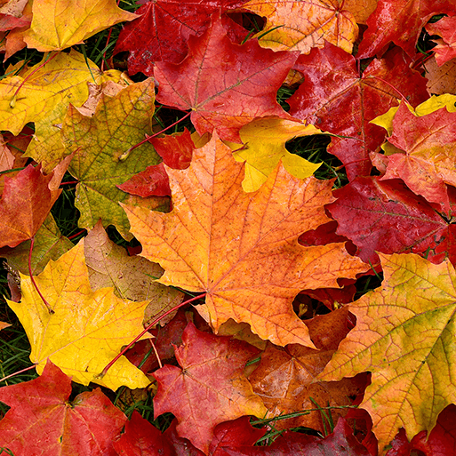 | This project supports children with settling into the new rules and routines of school and encourages them to make new friends and feel confident in their class. It teaches children about being helpful, kind and thoughtful at home and at school. This project also teaches children how they are unique and special, the importance of friendship and how people in their family, school and local community are important and can help them.  Key Texts: The Lion and the Mouse  Once There Were Giants  Lost and Found  People Who Help Us  This project teaches children about the natural changes that happen during the season of autumn, including how the weather changes, why trees lose their leaves and how wild animals prepare for winter.  Key Texts:  Leaf Man
Autumn 2 | Once Upon a Time    Sparkle and Shine   | This project supports children to develop a love of stories and reading. It encourages children to learn, retell and act out familiar and traditional tales including Cinderella, Goldilocks, Little Red Riding Hood, The Three Little Pigs and The Three Billy Goats Gruff.  Key Texts: Goldilocks and the Three Bears  Little Red Riding Hood  The Three Billy Goats Gruff  The Three Little Pigs  Cinderella  This project teaches children about the celebrations that take place during the autumn and winter seasons, and focus on the significance and symbolism of light at this time of year.  Key Texts: Little Glow
Spring 1 | Starry Night    Winter Wonderland   | This project explores the differences in the world at night compared to during the day. It teaches children about the importance of a good night’s sleep, and helps them to discover what is happening in the world while they are sleeping, including finding out about nocturnal animals.  Key Texts: Whatever Next!  Peace At Last  Owl Babies  How to Catch a Star  This project teaches children about the changes that happen during winter, including the types of weather associated with winter. It also explores places that have snow all year round and the types of animals that live there.  Key Texts: The Gruffalo’s Child
Spring 2 | Dangerous Dinosaurs  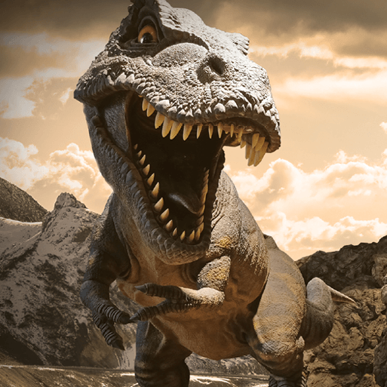  Puddles and Rainbows  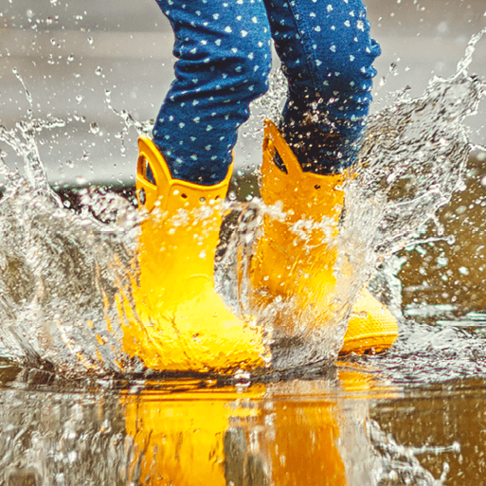 | This exciting project teaches children about the different animals that roamed Earth millions of years ago and how they are related to animals that live on Earth today.  Key texts: If I had a dinosaur by Gabby Dawnay.  Dear Dinosaur  Tyrannosaurus Drip  Little Kids First Big Book of Dinosaurs  Cave Baby  This mini project teaches children about the weather that happens during spring and allows them to explore natural phenomena, including rainbows. It supports them to explore colour in the natural world.  Key Texts: The Colour Monster
Summer 1 | Sunshine and Sunflowers  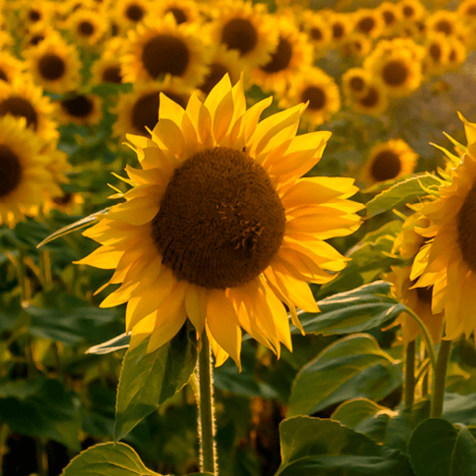  Shadows and Reflections   | This seasonal project provides opportunities for outdoor learning and teaches children how to care for the plants and animals in their local environment and how to stay safe in the sun.  Key Texts: My Butterfly Bouquet  Jump and Shout  Errol’s Garden  Shark in the Park!  This project teaches children about natural phenomena, including shadows, reflections and echoes. They explore how shadows are formed and how they can change.  Key Texts: Little Beaver and the Echo  Through the Magic Mirror
Summer 2 | Big Wide World    Splash  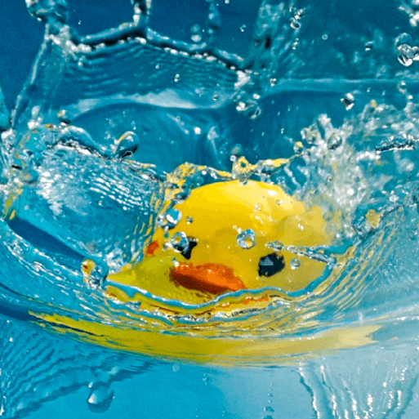 | This project teaches children about the global community to which they belong and explores how living things, communities and climates differ around the world.  - Key texts: Under the Same Sky by Britta Teckentrup  - Clean Up! by Nathan Bryon  - All Are Welcome by Alexandra Penfold  - Our World: A First Book of Geography by Sue Lowell Gallion  - Penguin on Holiday by Salina Yoon.  This project teaches children about water, including floating and sinking, freezing and melting, and why it is important for living things to stay hydrated.  Key texts: Water, Commotion in the Ocean.

