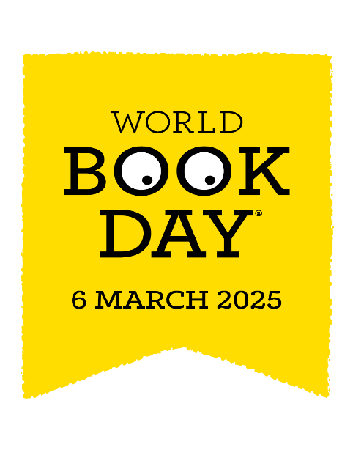
Dear parents, carers and pupils,
We are very excited to celebrate World Book Day this year with you all. In this letter you will find news of all the activities we will experience on the day and the competition to have a go at in preparation for it.
ACTIVITIES- To begin the day we are asking parents to join their child in class to share a story and a craft activity (9AM-9:45am). During the day there will be more fun booky activities including a story trail.
COMPETITION- Before World Book Day we will be sending home a paper plate for you to turn into a character from a book (see examples below). Please bring your design back to school by 6th March to enter. These designs will be on display in the hall for all to see and winners from each year group will receive a prize.
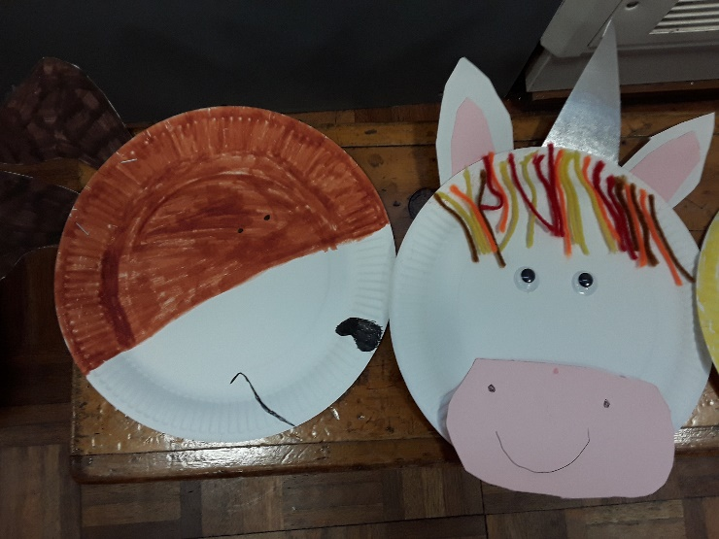
COSTUMES- On World Book Day this year we are inviting everyone to come to school in their pyjamas or onesies ready for a cosy, relaxing day reading. Bring your slippers too for wearing inside school.
Please talk to your class teacher if you need any tips or inspiration. In assembly on the day we will have a parade around the hall to share our costumes.
Happy Reading!
Mrs Hall

