
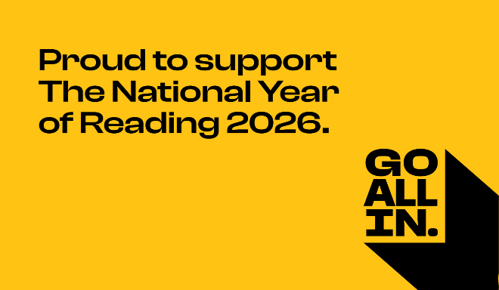

15/1/26
Dear parents and carers,
Here, at Bishop Pursglove Primary, we are very proud to support The National Year of Reading promoted by The National Literacy Trust. Throughout the year we will hold monthly activities to promote and celebrate reading with our school community, parents and the wider community. Please join us for an amazing year of reading! A little reading can go a long way. It can connect us to others, spark curiosity, boost our self-esteem and support our mental health.
National Storytelling Week 2nd- 8th February
To open this year of reading we would like to invite you to join your child’s class for story time on Monday 2nd February at 3pm.
Also, if any family members would like to come and be the storyteller and share a book with your child’s class please do speak to the class teacher and set up a day that is best for you. This would be very informal and relaxed. You could read a story, show some books you enjoyed as a child or review a book you have enjoyed reading to your own family. We are keen to provide our pupils with as many positive reading models as possible and you are all welcome.
Here’s to a great year of reading! Let’s GO ALL IN!
Thank you,
Fiona Hall

