At home and at the synagogue
Jewish people have many items in their homes which help them show that they follow the Jewish faith.
This may include a mezuzah box which contains the Shema, a very important prayer from the Torah which tells Jews about their relationship with God. The mezuzah box can be seen on doorposts in Jewish homes and Jewish people will touch it as a reminder of their faith.
Sometimes there will be a Star of David on a mezuzah box or somewhere else in a Jewish home to show people that the home is a Jewish home. You can also find a Star of David in a synagogue to show it is a Jewish place of worship.
Some Jewish people will also keep Shabbat when they will not work or travel and will have a special meal to remember the day God rested when he had created the world. Many Jewish people will also go to the synagogue to show what an incredibly important day it is.
Jewish people will also have celebrations and festivals throughout the year to remember specific events and important times. One of those is the festival of Chanukah which helps Jewish people remember when there was only enough oil to keep the temple menorah lit for one day but it stayed alight for eight days. Some of these stories are in the Torah such as the story of David and Goliath.

Synagogue: the Jewish place of worship, sometimes called a shul
Torah: the Jewish holy book made up of the five books of Law.
Jewish: relating to the religion of Judaism.
Mezuzah: a small scroll with words from the Torah written on it and contained in a smack rectangular mezuzah box
Shabbat: a day of rest for Jewish people, the seventh day of the week
Shema: A Jewish prayer
God: all powerful being who Jewish people believe created the world
Chanukah: a Jewish festival that remembers the winning back of the Second Temple and the miracle of the tiny amount of oil.
Dreidel: a four-sided spinning top played during the festival of Chanukah
Star of David: the recognized symbol of Judaism
Important information
So how does it all work?
Wonderful words
Who is Jewish and how do they live?
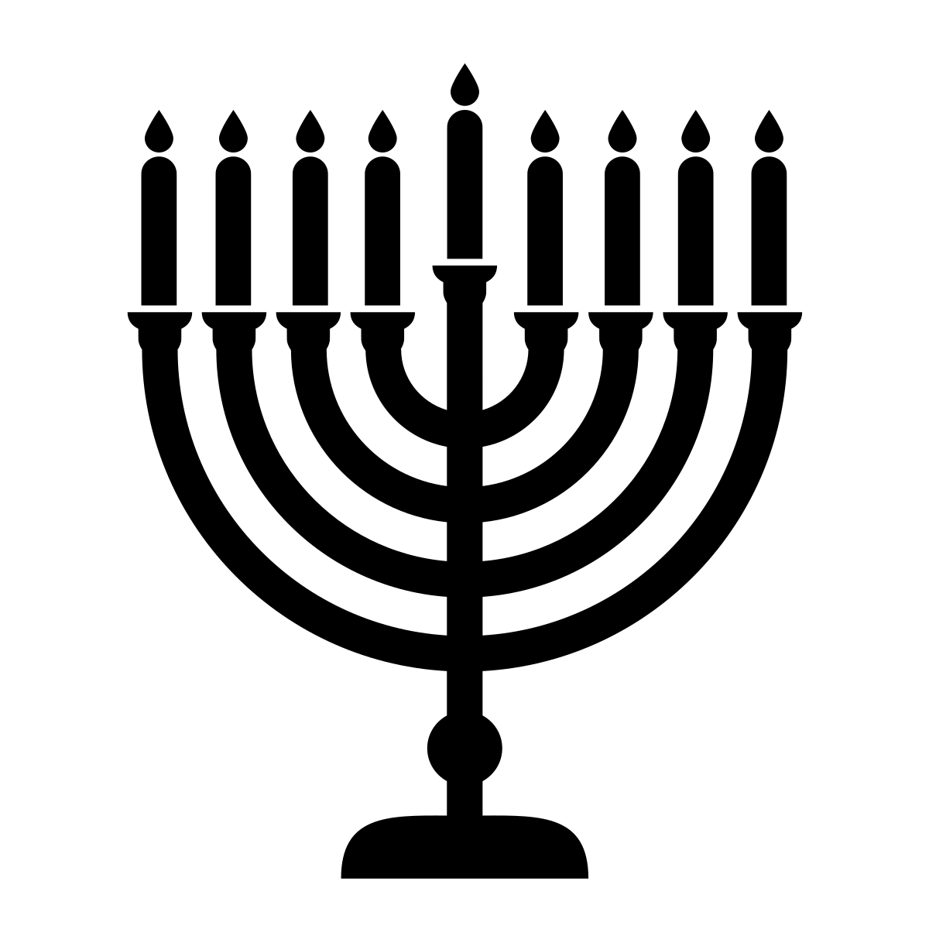
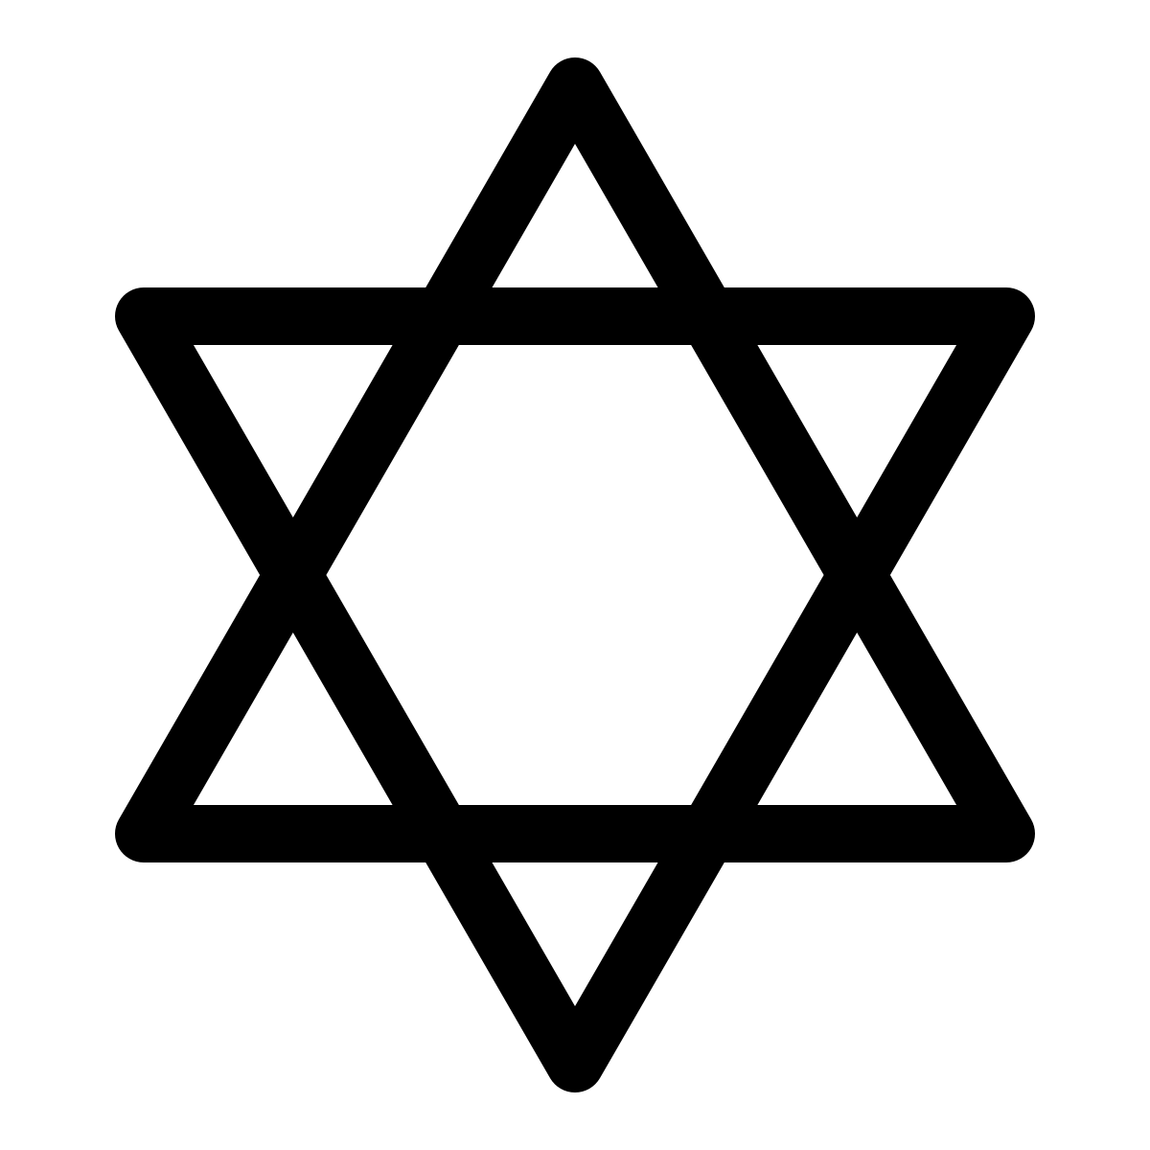
Festivals and celebrations
Following the Jewish Faith
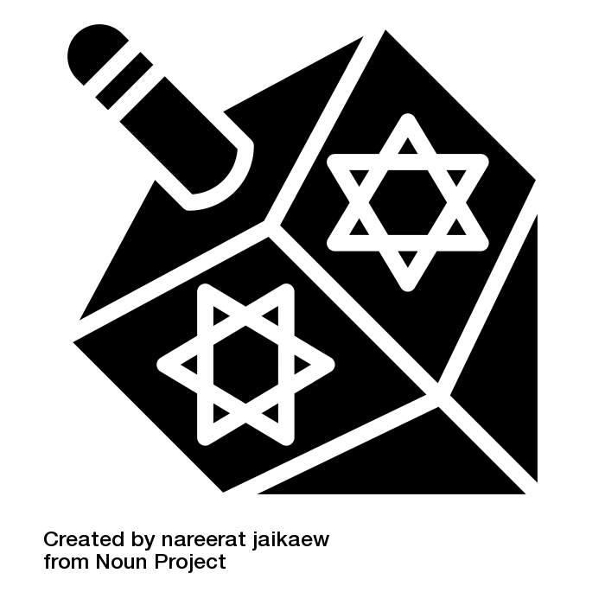
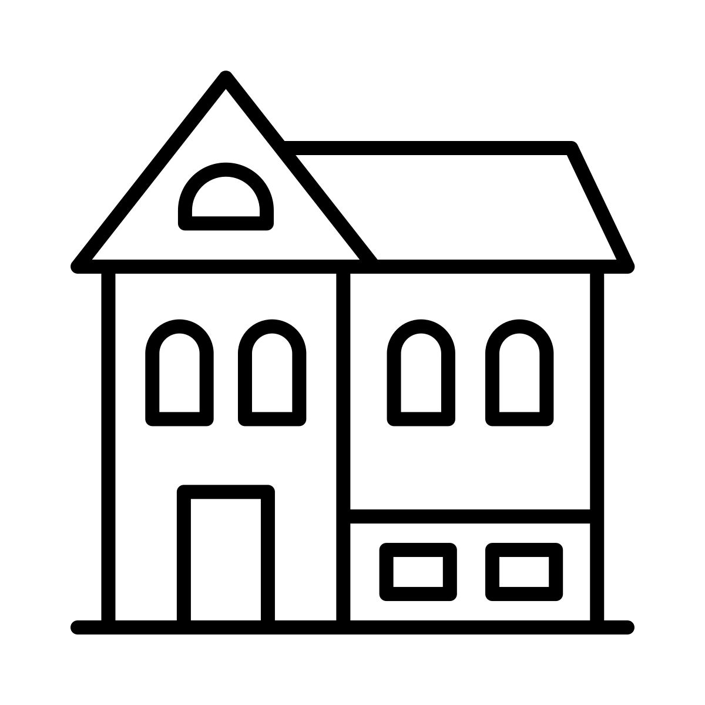
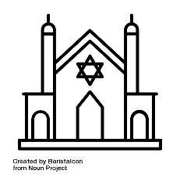

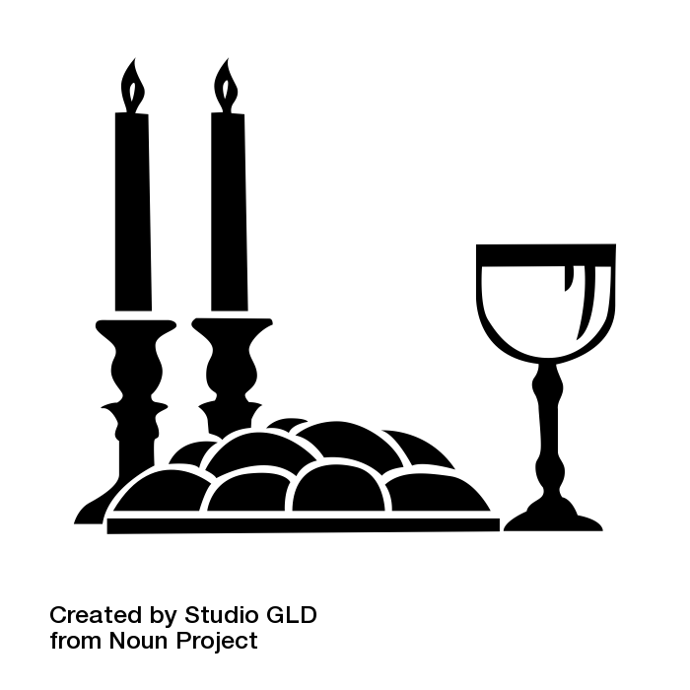
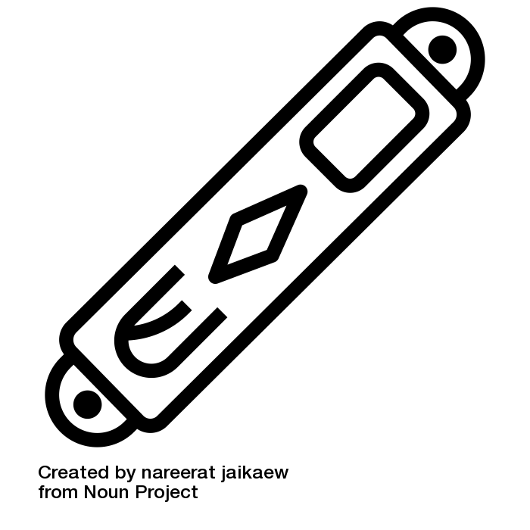
All icons are used free of charge from Noun Project.
Individual artist credit is given on the following slide.
Year One – Knowledge Organiser
UNIT
9
Year One
Knowledge
Organiser

